HANDICRAFTS OF PUNJAB

Punjab Arts & Crafts is highly acclaimed the world over. Punjab is a culturally rich north western state of India. The Arts and Crafts of Punjab include the variety of handiworks. The artisans of Punjab are skilled and dexterous. The women of the villages are mainly involved in carrying out the Punjab Arts & Crafts.

The Mud Works is an ancient practice in Punjab. Generally it is a trend in Punjab to plaster the walls of the house with mud and then create different motifs and designs on them. These kind of works are generally performed by the rural women of Punjab. The carpenters of Punjab are renowned for their skills in Wood Works. The carpenters generally make the comfortable beds. The carved legs of these beds were known as the Pawas. The carpenters are apt in making Peeras or Peerians, decorative boxes, pidhis and toys. The Metal Work is also very popular among th Punjab Arts & Crafts. The metal utensils are used in households and for religious purpose. The Basketry were made mainly for household usage. The Basketry works are done by shaving the thin straws of grass. These straws are used to weave mats, rugs, carpets, curtains and hand fans. The needle work or the Weaving and Embroidery in Punjab is known by various names as they are associated with some of the nice aspects of life and they are skillfully made by the beautiful village girls.The hand fans are made almost in the same way as the Phulkaris. Phulkari is an intricate needle work. Often the base cloth is covered entirely which is known as Bagh. The smaller the stitches, the Phulkari becomes finer and better. The Juttis made in Punjab are world famous The motifs of The Juttis of Punjab are embroidered with threads of silver and gold.  
  
**Mud Work**  
  
The Mud Works is an ancient practice in Punjab. It is a skill of the artisans of Punjab to transfer dull objects into magnificent work of art. Generally it isa trend in Punjab to plaster the walls of the house with mud and then create different motifs and designs on them. These kind of works are generally performed by the rural women of Punjab. Earlier the Mud Works were done due to certain superstitions to keep away the evil spirits from the households. This art of painting mud walls is known as Chowk-Poorana in Punjab. Mainly the Mud Works were done during the festivals in the village, like the Navaratra poorna, Karva-Chauth, Hoi or Ahoi, and Diwali. 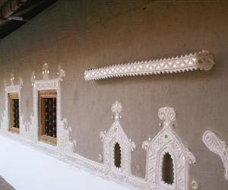  
  
**Weaving and Embroidery**  
  
The weaving of durries are very common with the Punjabi women. Durries are actually made by cotton used as floor or bed spreads. There are different motifs like stripes, squares, checks are prevalent. Sometimes motifs of animals and birds are also made.  
  
The needle work or the Weaving and Embroidery in Punjab is known by various names as they are associated with some of the nice aspects of life and they are skillfully made by the beautiful village girls. But in Punjab, Weaving and Embroidery forms the part of daily lives of the women of the village. On certain auspicious occasions and festivals, these works of Weaving and Embroidery are highly used. Some of the needle works are called Phulkari meaning flower works and Baghs meaning garden. The needle work are mainly done on the scarves, bed spreads, salvars, shirts, and dupattas. Thus a feminine touch in the Weaving and Embroidery of Punjab make it all the more special.  
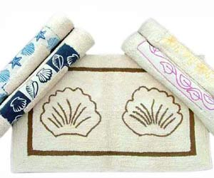

**Durries  of punjab**

Durries are the flat woven rugs that are functional as well as striking in nature. They are used either as carpets on the floor or as bed sheets. What makes them distinct from the normal carpet and the bedcover is the intricate blend of artistic designs. The bright presentation of artistry in Punjabi durries adds to decor of the room. Initially made for the countryside usage, durries now form an integral part of urban homes. They present a distinct blend of both tradition and modernization, in a composed harmony.

**Popularity**  
Durries are gradually gaining importance over the carpets. The reason is that durries are easy to maintain. They are lighter and are easy to move and clean. Besides, they are highly economical, suiting the common man's pocket. They are available in every style, ranging from the casual to the gorgeous ones. Durries are widely available all over Punjab. However, the main centers producing durries are Amritsar, Nikodar, Jalandhar, Hoshiarpur and Anandpur Sahib. Mani Majra, on the outskirts of Chandigarh, produces distinct durries with special patterns and designs. Durries of Mani Majra stand different from the durries produced elsewhere in Punjab.

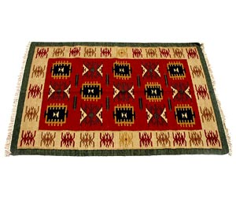

**Juttis of Punjab**

Punjabi juttis represent the traditional footwear of Punjab, which is known worldwide for its exquisite design and intricate pattern. It can be described as a traditional Indian shoe, which some other states like Rajasthan and Haryana also manufacture. However, the name 'jutti’ is typical to Punjab, whereas similar traditional footwear is called khussa or mojri in other states. Juttis are long shoes with a curved end. They are made out of self-lured leather. Gold and silver threads are used to weave embroidery on them.

There is a rich display of artistry in Punjabi jootis. They are exceptionally colorful and extraordinarily traditional. There is a wide use of fancy materials like beads, pearls, coloured threads, small mirrors and seashells. Light juttis are considered the best. It is said that they are so light that even the sparrows can fly away with them. They are designed in such a way that they give an ethnic Indian look to the wearer, combined with a royal appearance. Utility, along with beauty, is the main concept behind the production of juttis. Dressed like sherwani are incomplete without the grace of a jutti.  
  
The designs of Punjabi juttis are inspired by the footwear that was worn by the royal people during Mughal period. Usually, they have a curved toe, which sets them apart from other footwear. They consist of a network known as 'jaali’, which is made up of the mixture of variety of threads. Juttis come in wide varieties; some of the popular ones are the King wedding jutti, style jutti, khausa jutti, punch zari and comfort juti, energise jutti and mesmeric embroidery jutti.

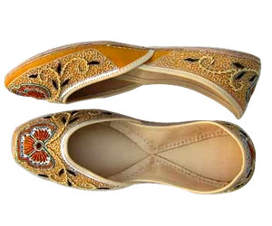

**Punjabi Paintings**

In the grand collection of Punjabi arts and crafts, one name that deserves a mention is the mural paintings and frescoes. These types of paintings are mainly done on permanent surfaces like walls, ceiling, gates etc. Punjabi people, by nature are lively and juvenile. In Punjab, you find color in everything you look for - be it their costumes, festivals, living style or arts and crafts. Punjabi people are very fond of decorating their homes and shrines. Mural paintings and frescoes are the main forms of paintings flourishing in the state. Most of the villages in Punjab have huge gates painted with the images of animals or scenes from the life of Sikh Gurus, national sports and festivals or some pictures from the battlefield. The ancient city of Amritsar, Patiala, Gurdaspur, Hoshiarpur, Kapurthala and Faridkot have grand historic buildings displaying the splendor of the rich mural paintings and frescoes of the golden days.  
  
**Paintings of Punjab  
  
Paintings in Amritsar**  
Most enchanting sights of Punajbi paintings can be seen in Harmandir Sahib, Akhara Bala Nand, Tower of Baba Atal Rai and Ranjit Singh Musuem, in Amritsar. The sanctum of Harmandir Sahib has 300 stunning designs of paintings engraved in stone-inlay and mirror work, belonging to the typical Punjabi-genre. At Maharaja Ranjit Singh Musuem, the most remarkable feature is the set of ivory miniature paintings of the chiefs. Baba Atal Rai Tower has a gallery of wall paintings, stone-inlay and metalwork. A room in Akhara Bala Nand, near the Golden temple, has its walls engraved with the frescoes of religious themes.  
  
**Paintings in Patiala**  
Qila Mubarik Androon in Patiala is well known for its rich collection of paintings. These paintings have been designed by the great artists of Kangra and Rajasthan. They depict the themes of Ramayana, Mahabharta, Shrimad Bhagwat, Geet Govinda, Baramas and Ragas and Ragnis. The legends of Laila Majnu, Sassi Punnu and Sohni Mahiwal are also painted in one of the bedchambers.  You find a splendid exhibition of mural paintings on the walls of Sheesh Mahal as well. The paintings are a translation of the poetry of Keshav Dass, Bihari Lal and Surdas. Themes from mythology, legends, Ramayana, Nayak-Nayika and Baramasa are also depicted. There is a painting of the Guru Nanak Dev sitting under the tree, flanked by Bhai Bala and Bhai Mardana. There are also representations of the Sikh royalty and aristocracy like Maharaja Ranjit Singh, Mharaja Dalip Singh and Dhian Singh Dogra.  
  
**Other Paintings**  
The famous Raghunath Temple in Gurdaspur, built by Maharaja Ranjit Singh, contains some of the rich fresco paintings belonging to 19th century. Thakar Dwara of Bairagas, in Hoshiarpur, is full of mural and fresco paintings depicting socio-religious themes. Themes ranging from simple daily life activities, like a lady feeding a parrot, to the religious themes are presented here candidly. Shekuhpua temple in Kapurthala, constructed by Diwan Saudagar Mal, has a small sanctum encircled by broad path that contains variety of mural paintings. Gurudwara Baba Mati Sahib in Jalandhar and Gurudwara Harshai in Faridkot consist of some of the best mural paintings.

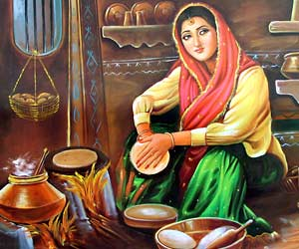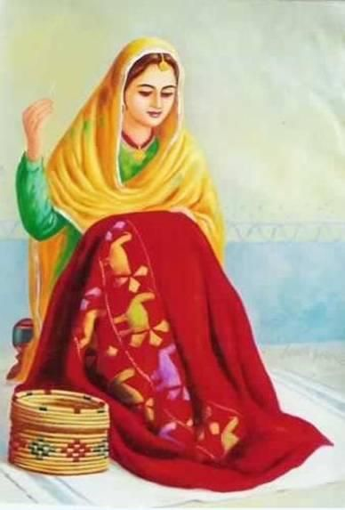

**Punjabi Paranda**

[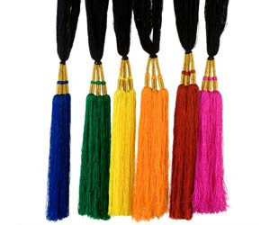](https://1.bp.blogspot.com/-vt2s6Q6NNN0/Wb9nLraI9vI/AAAAAAAAAO4/bU23NKq-o7kZJtPspKc8Kl--19kmvPYpgCLcBGAs/s1600/wrt.jpg) 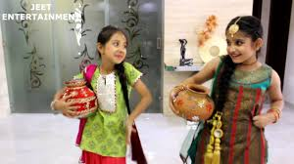

Paranda is one of the traditional handicrafts of Punjab. It is a colorful hanging worn by the Punjabi women in their hair. Most of the Punjabi women have long hair, which they plait and then tie a paranda at the end. Parandis are available with a great variety in designs and colors. They are made out of a bunch of silk threads, intricately woven with other skillful works. The craftsmen require a great deal of patience and creativity while producing the parandas. They reflect the natural liveliness and spontaneity of the Punjabi people.  
  
In Punjab, parandas are available in different types, each one of them designed for a specific occasion. The villages in the districts of Jalandhar, Amritsar, Nakodar, Hoshiarpur and Ludhiana are mainly engaged in the handicraft industry of parandi. Though paranda-making is not as exotic as the carpet weaving craft, the market for them is widely growing throughout the country. Paranda is now extensively used by women all over India, particularly during special occasions. It has a great appeal for foreigners as well, owing to its uniqueness and brightness.

**Wood Works**  
  
Among the Art and Craft of Punjab the Woods Works are very famous. It has been a long tradition of the carpenters of Punjab to make different objects out of wood. The wooden works made in Punjab are highly appreciated the world over. The tourists visiting Punjab collect a memento of the handiworks of Punjab.  
  
The carpenters of Punjab are renowned for their skills in Wood Works. They have been traditionally popular through the ages. It is also a much practiced occupation among the villagers of Punjab. The carpenters generally make the comfortable beds with back rests that are fitted with mirrors. The carved legs of these beds were known as the Pawas. The carpenters of Punjab are also apt in making the comfortable low seats called Peeras and Peerians. This piece of furniture are made in almost every village of Punjab.

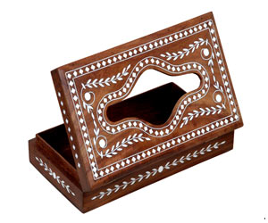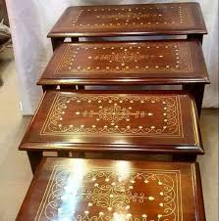

**Basketry**  
  
Punjab Art and Craft includes the fascinating and indigenous work of Basketry. Mainly the women folk of the villages of Punjab are engaged in the work of Basketry. Some of the Basketry works of Punjab is known world over. The weaving of baskets and similar objects have been a traditional practice among the Punjabis.  
  
The Basketry were made by the village people mainly for household usage. But in the recent days, it has become a trend to identify these handicraft articles as show pieces or for decorative purposes in the urban homes.  
  
The Basketry works are done by shaving the thin straws of grass. These straws are used to weave mats, rugs, carpets, curtains and hand fans. These hand fans are known as Peshawari Pakkhe. The fans comparatively of smaller size is known as Kundaldar Pakkhi. These fans are small and delicate and have beautiful curl ends. The fans made by weaving are object of fascination to the tourists in Punjab.

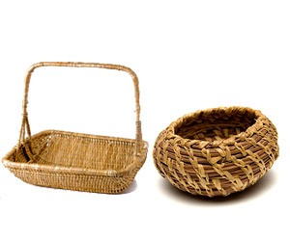

**Folk Toys**  
  
The conventional handicraft industry of Punjab produces beautiful "Folk Toys" that reflect the rich cultural tradition of one of the most vibrant and dynamic state of Punjab. The folk toys of Punjab represent the artistic skills and imaginative creations of the people of Punjab. The "Folk Toy" industry is an important handicraft industry of Punjab that strengthens the financial condition of the state.  
  
Since the inception of the industry, it has produced many exemplary products that captivates the spectators with its attractive and colorful appearance. The toy industry flourished during the days of the Indus Valley Civilization when the craftsmen manufactured many beautiful toys and artifacts for the children.  
  
The tradition of making toys was carried down the ages and the villagers of Punjab produced a wide variety of toys to satisfy their artistic zeal. The toy industry of the by gone days received a further boasts after the Independence of our country when the Government of the state proposed and implemented several policies to promote growth of the handicraft industry.

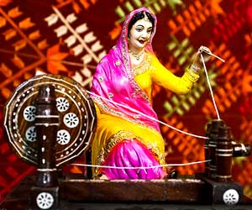 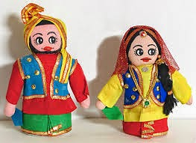  
  
**Dolls**  
  
Keeping in trend with the lively and colorful traditional culture of the state, the craftsmen of Punjab are apt in producing attractive and beautiful "Dolls". The handicraft industry of Punjab is one of the most flourishing and lucrative industry of the state. The beautifully decorated and adorned Dolls of the handicraft industry of Punjab represent the dynamic and vibrant culture of the state.  
  
One of the most fascinating industry of the state, the "Dolls" portray the artistic caliber of the people of Punjab. The craftsmen make dolls of various sizes and kinds. The Dolls have a great demand within and outside India. Almost all the districts of Punjab have flourished in the art of Doll Making. However, the city of Chandigarh has become one of the important centers of "Doll" making. The Dolls of Punjab have an internationally acclaimed status that are purchased by the tourist for their near and dear ones as a token of love and appreciation.

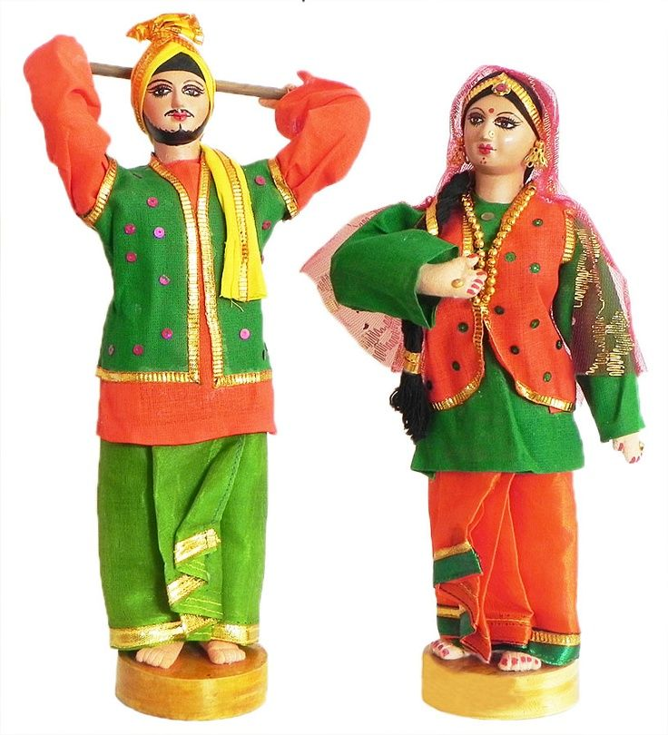  
  
**phulkari**  
  
Phulkari is a traditional pattern of weaving in Punjab. It is popular with the women of Punjab from the15 th century. Among the Art and Craft of Punjab, Phulkari is the most popular handiwork in India and abroad. Phulkari is mainly associated with flower embroidery.  
  
Phulkari is associated with embroidering over the dupattas and shawls. It is an intricate needle work. Often the base cloth is covered entirely which is known as Bagh meaning garden of flower. It mainly depends on the size of the stitching. The smaller the stitches, the Phulkari becomes finer and better. But the art of Phulkari is not very complicated. The needle work gives rise to the different motifs and design on the piece of cloth. In the earlier days, the threads used for embroidery were of silk.  
  
The bright colors that are generally used for Phulkari are red, orange, blue, green, crimson etc. For the Phulkari of Punjab, only one single strand is being used at a time. The stitches in the Phulkari are done vertically, horizontally and even diagonally to create a special effect of light and shade.  
  
The designs of the Phulkari of Punjab vary from one village to another. The embroidery work is given descriptive names of their own. The sainchi Phulkari are much in demand and it depicts the scenes from the village life. The skill and emotions of the rural girls got associated with this embroidery work. Phulkari often became a part of the bridal trousseau.  
  
The Phulkari works are used in various occasions like festivals, marriages, religious ceremonies in Punjab. It was made only for the personal usage by the rural women. But it has been so much in demand that it is also exported to Middle East.

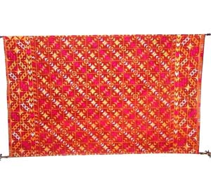 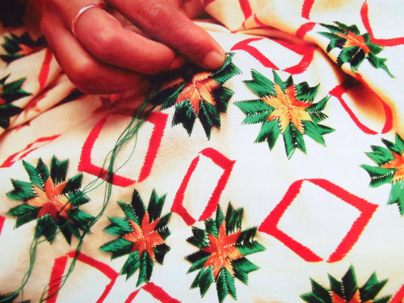

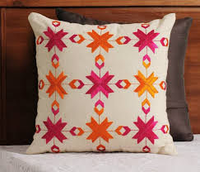  
**Pidhis**  
  
Comfortable, attractive and the eloquently decorated "Pidhis" of Punjab are some of the splendid products of the handicraft industry of Punjab. During the olden days when there was hardly any concept of "Modular Kitchen", the Punjabi women preferred to sit in the four legged small stool that were very comfortable and usable as well. However the "Pidhis" or the short stools are still in vogue, not only in Punjab but in the other states as well. The small stools that are beautifully designed by the craftsmen of Punjab now serve a variety of purpose and are used on several occasions to suit the convenience of the user.  
  
The "Pidhis" or the small stools are made up of woods. To add to the beauty of the stools, the craftsmen design the stools with colorful threads to give it a majestic look. The splendid small and short stools are very attractive that display the artistic skills and the creative imagination of the people of the state. To give a traditional and a royal touch to the splendid houses the owners use the beautifully adorned stools . This marvelous creation of the traditional handicraft industry of the state has a wide market within and outside India.  
  
The "Pidhis" of Punjab are long lasting and convenient for the customers. Some of the other attractive products of this industry are the colorful dolls, and table lamps that have a great demand. This industry of making the "Pidhis" and other wooden goods have flourished in the districts of Karatpur, Jalandhar and Hoshiarpur where most of the people have mastered the art of producing such wonderful artistic creations that requires patience and diligence.

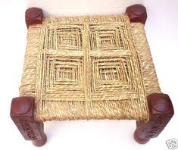  
  
**Traditional Ornaments**  
  
Representing the vibrant and dynamic nature of the state, the people of Punjab flaunt several "Traditional Ornaments" during festivals and other important occasions. From time immemorial, the conventional jeweleries are a symbol of power, wealth and status. In the modern industrial society, the value of antique and conventional jeweleries have increased tremendously. Keeping in tune with the affluence of the Punjabi people, the traditional jeweleries have greater demand than the latest ones.

Punjab has always encouraged the use of heavy jeweleries during marriages and other occasions. The state has several industries that cater to the demands of the traditional jeweleries. The goldsmiths of the state create several conventional ornaments that displays their artistic skills and creative imaginations. The art of making jeweleries requires lots of patience and diligence. Some of the important traditional ornaments of Punjab that have a great demand in the other states as well are:

* **Turah-i- Marwarid**- It is a string of bright pearls that adorn the colorful turbans of the bridegroom
* **Sir Mang**- A long chain of gold studded with precious gems that a bride wears on her fore head
* **Karnphul, Jhumka and Dhedu**- This are the varieties of earrings that are worn by the ladies
* **Bala**- It is a huge earring made of gold that is worn by Khatri, Sikh and Dogra men
* **Nath**- It is a huge golden ring which is a symbol for married women
* **Chandanhar**- This is a necklace with many golden chains is worn by women during marriage

The traditional ornaments of Punjab is one of the lucrative industries of the state that earns lots of revenues. Men and women are fascinated by the traditional and conventional jeweleries whose glitter beauty captures the imagination of the poet.

